

Student: Rogoz Bogdan Dorin
Group: 30433

Table of Contents
Student: Rogoz Bogdan Dorin 1
1. Theme 3
2. Objective 3
3. Specifications 3
4. Abstract 3
5. History 4
6. Applications 4
7. Architecture 6
8. Data transmission 7
8.1. Collisions 9
8.2. Data Frame 10
8.3. Error Frame 11
8.4. Error checking and handling 11
9. Design 12
9.1. Functional requirements 12
9.2. Non-functional requirements 12
9.3. Models 12
9.4. UML Class Diagram 13
9.5. Component diagram 14
9.6. Scenarios 14
9.7. Graphical User Interface 15
10. Implementation 16
10.1. Frame package 16
10.2. CAN Controller and ECU 18
10.2.1. CAN Controller 18
10.2.2. ECU 19
10.3. Bus 21
11. Testing 21
12. Bibliography 21

1. Theme
The topic discussed in this paper is the CAN standard used within the automotive industry.

2. Objective
The objective is to provide an overview on CAN systems’ communications protocol. After finishing the paper, the reader should be able to understand the theoretical fundamentals behind the CAN 2.0A’s architecture and messaging protocol.

3. Specifications
This paper serves as an entry point on the road of building a fully-fledged CAN system, a simulator or the logic behind a CAN controller linking a certain microprocessor inside an ECU to the rest of the CAN Bus. By using the information presented, the engineer can make his way through learning the more advanced specifications of the CAN standard, in order to be able to build a fully-working system (including error checking, correction, bit stuffing etc.).

4. Abstract
A Controller Area Network (CAN) is a vehicle bus standard designed to allow microcontrollers and devices to communicate with each other in applications without a host computer. It is a message-based protocol, designed originally for multiplex electrical wiring within automobiles to save on copper, but is also used in many other contexts.

5. History
The CAN 1.0 protocol was released in 1986. The first CAN controller chips, produced by Intel and Philips, came on the market in 1987.
Bosch published several versions of the CAN specification and the latest is CAN 2.0 published in 1991. This specification has two parts; part A is for the standard format with an 11-bit identifier, and part B is for the extended format with a 29-bit identifier. A CAN device that uses 11-bit identifiers is commonly called CAN 2.0A and a CAN device that uses 29-bit identifiers is commonly called CAN 2.0B.
Bosch is still active in extending the CAN standards. In 2012, Bosch released CAN FD 1.0 or CAN with Flexible Data-Rate.

6. Applications
The modern automobile have large numbers of ECUs (Electronic Control Units) and it is essential that they are capable of intercommunicating. Before CAN systems became available, the intercommunications system occupied large amounts of space and quickly became hard to develop and test.
Let’s give the following example: suppose we have the following ECUs on our vehicle:
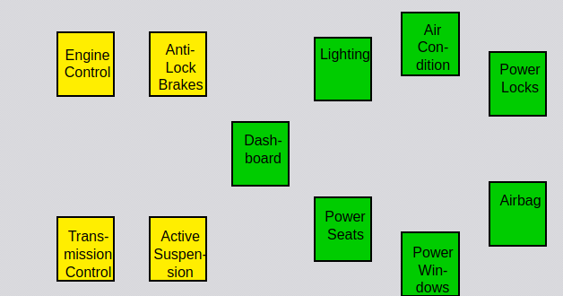
Interconnecting these ECUs in a traditional way would result in this:
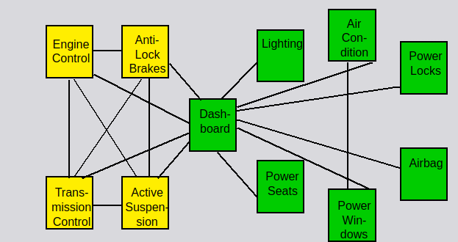
Of course, such wiring (point-to-point wiring) would produce high material costs, high time delays and reliability problems. On the other hand, using a CAN architecture produces the following system:
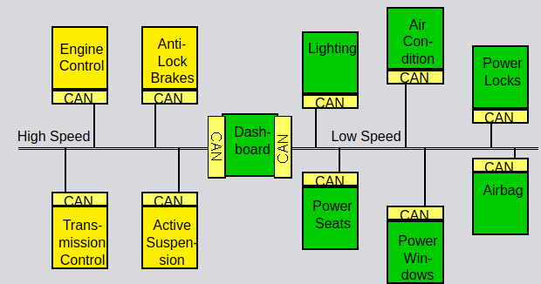
This change results in a more simplistic, cost-effective design. In this example, two CAN standards were used (the High Speed and Low Speed / Fault Tolerant), depending on the designer’s preferences on each ECU’s maximum data transfer latency.
As a result, different ECUs are able to intercommunicate and perform certain actions, including:
- Auto start/stop: If the car’s sensors detect that the vehicle has been stationary for a while, they can send the Engine Control ECU the signal to shut down in order to improve fuel economy and emmisions.
- Air condition: If the driver activates the air contitioner, the dashboard will send a message through the Low Speed CAN to the Air Condition ECU
- Automatic door locks: If the car is stationary for a while or the driver presses a certain button, the dashboard could send a message to the Power Locks ECU in order to lock all the doors. The same components are present in the case of unlocking the doors.

7. Architecture
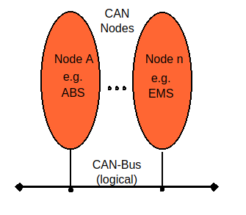

CAN is a multi-master bus with an open, linear structure with one logic bus line and equal nodes. The number of nodes is not limited by the protocol.
In the CAN protocol, the bus nodes do not have a specific address. Instead, the address information is contained in the identifiers of the transmitted messages, indicating the message content and the priority of the message.
The number of nodes may be changed dynamically without disturbing the communication of the other nodes. Multicasting and Broadcasting is supported by CAN.

8. Data transmission
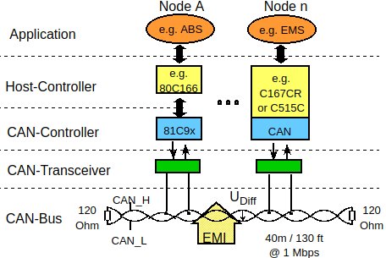

CAN provides sophisticated error-detection and error handling mechanisms such as CRC check, and high immunity against electromagnetic interference. Erroneous messages are automatically retransmitted. Temporary errors are recovered. Permanent errors are followed by automatic switch-off of defective nodes. There is guaranteed system-wide data consistency. The CAN protocol uses Non-Return-to-Zero or NRZ bit coding. For synchronization purposes, Bit Stuffing is used. Message length is short with a maximum of 8 data bytes per message and there is a low latency between transmission request and start of transmission.
There are two bus states, called "dominant" and "recessive". The bus logic uses a "Wired-AND" mechanism, that is, "dominant bits" (equivalent to the logic level "Zero") overwrite the "recessive" bits (equivalent to the logic level "One" ).

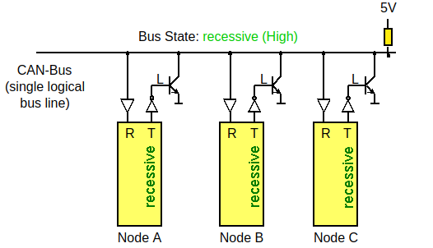
Only if all nodes transmit recessive bits (ones), the Bus is in the recessive state.

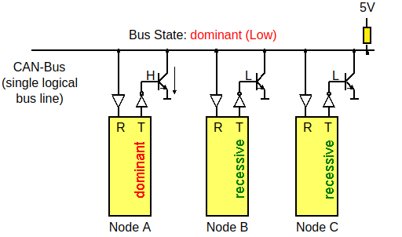

As soon as one node transmits a dominant bit (zero), the bus is in the dominant state.

8.1. Collisions
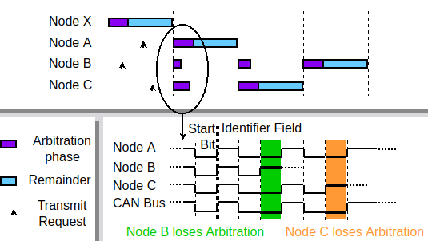
If two or more bus nodes start their transmission at the same time after having found the bus to be idle, collision of the messages is avoided by bitwise arbitration. Each node sends the bits of its message identifier and monitors the bus level.
At a certain time nodes A and C send a dominant identifier bit. Node B sends a recessive identifier bit but reads back a dominant one. Node B loses bus arbitration and switches to receive mode. Some bits later node C loses arbitration against node A. This means that the message identifier of node A has a lower binary value and therefore a higher priority than the messages of nodes B and C. In this way, the bus node with the highest priority message wins arbitration without losing time by having to repeat the message.
Nodes B and C automatically try to repeat their transmission once the bus returns to the idle state. Node B loses against node C, so the message of node C is transmitted next, followed by node B’s message.
It is not permitted for different nodes to send messages with the same identifier as arbitration could fail leading to collisions and errors.

8.2. Data Frame
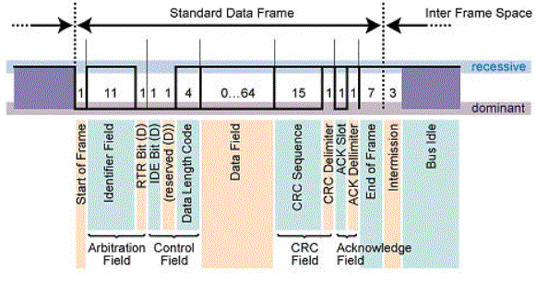
A "Data Frame" is generated by a CAN node when the node wishes to transmit data. The Standard CAN Data Frame is shown above. The frame begins with a dominant Start Of Frame bit for hard synchronization of all nodes.
The Arbitration Field consists of 12 bits: The 11-bit Identifier, which reflects the contents and priority of the message, and the Remote Transmission Request bit. The Remote transmission request bit is used to distinguish a Data Frame (RTR = dominant) from a Remote Frame (RTR = recessive).
The Data Length Code (DLC) specifies the number of bytes of data contained in the message (0 - 8 bytes). The data being sent follows in the Data Field which is of the length defined by the DLC above (0, 8, 16, ...., 56 or 64 bits).
Seven recessive bits (End of Frame) end the Data Frame.

8.3. Error Frame
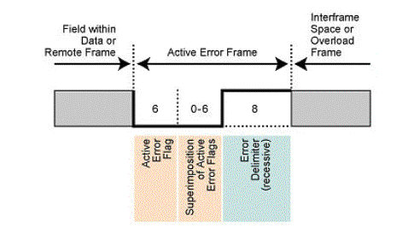

An Error Frame is generated by any node that detects a bus error. The Error Frame consists of 2 fields, an Error Flag field followed by an Error Delimiter field. The Error Delimiter consists of 8 recessive bits and allows the bus nodes to restart bus communications cleanly after an error.

8.4. Error checking and handling
The CAN protocol provides sophisticated error detection mechanisms. These mechanisms are:
- Cyclic Redundancy Check: the transmitter calculates a check sum for the bit sequence from the start of frame bit until the end of the Data Field.
- Acknowledge Check: checks in the Acknowledge Field of a message to determine if the Acknowledge Slot contains a dominant bit.
- Frame Check: If a transmitter detects a dominant bit in the CRC Delimiter, Acknowledge Delimiter, End of Frame or Interframe Space, then a Form Error has occurred.
- Bit Check: if a transmitter either sends a dominant bit but detects a recessive bit on the bus line or sends a recessive bit but detects a dominant bit on the bus line, then a Bit Error occurred.
- Bit Stuffing Check: if six consecutive bits with the same polarity are detected between Start of Frame and the CRC Delimiter, the bit stuffing rule has been violated.
Detected errors are made public to all other nodes via Error Frames. The transmission of the erroneous message is aborted and the frame is repeated as soon as possible.

9. Design

9.1. Functional requirements
The user should be able to:
- Add CAN controllers without affecting the other controllers’ functionalities
- Remove CAN controllers without affecting the other controllers’ functionalities
- Define the behavior of his controllers based on a template
- Load simulations
- Save simulations
- View the bus data and the timestamps

9.2. Non-functional requirements
The following requirements should be satisfied:
- The bus and each controller should represent a different thread, in order to simulate the concurrency of the components
- The Observable pattern should be used, in order to simplify data transmission

9.3. Models
The following models are implemented:
- Frame : represents a “builder” object which transforms a set of parameters into valid CAN frames; a frame can be of multiple types
- DataFrame : represents the data frame used by the CAN protocol. It builds a message based on the fields’ values; it is used for sending data, usually as a response to a request
- RemoteFrame : represents the remote frame used by the CAN protocol; it is used for sending requests to remote controllers
- ErrorFrame : represents the error frame used by the CAN protocol; it is instatiated when an error is detected by the CAN controller
- OverloadFrame : represents the overload frame used by the CAN protocol.
- Bus : represents a CAN bus; multiple instances are possible
- CANController : represents an endpoint of the CAN bus; it reads from and writes to the CAN bus; it is also responsible for checking if the received messages are errorneous
- MicroController : represents a microcontroller which does a certain job; it communicates with the CAN bus through the CAN controller

9.4. UML Class Diagram
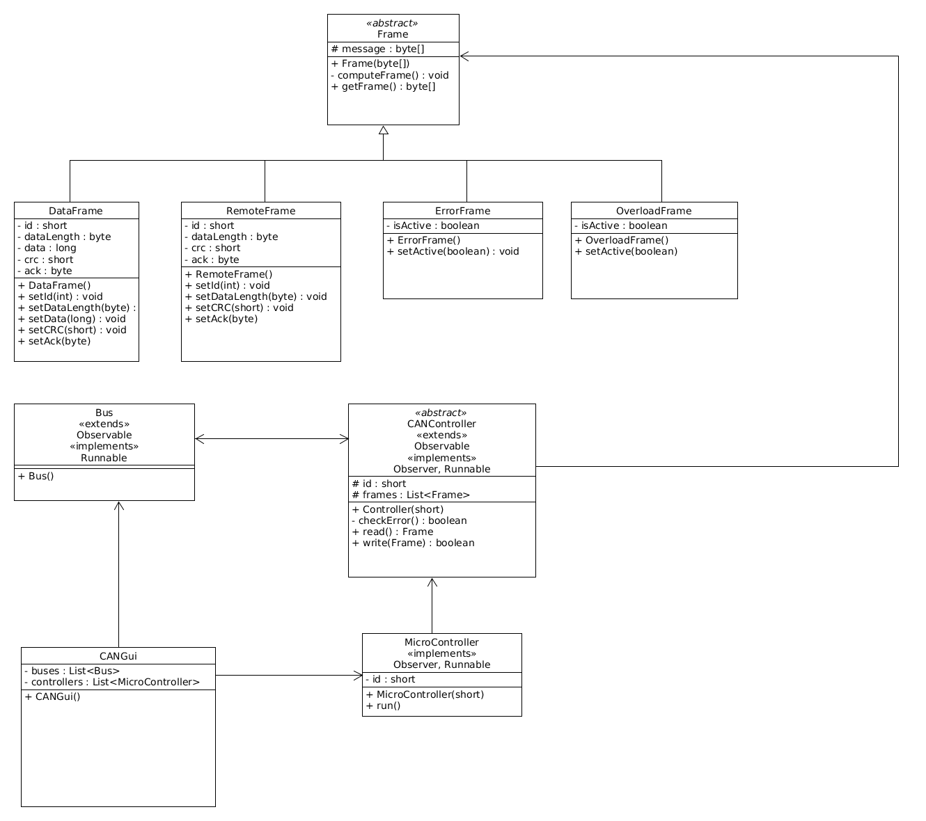

9.5. Component diagram
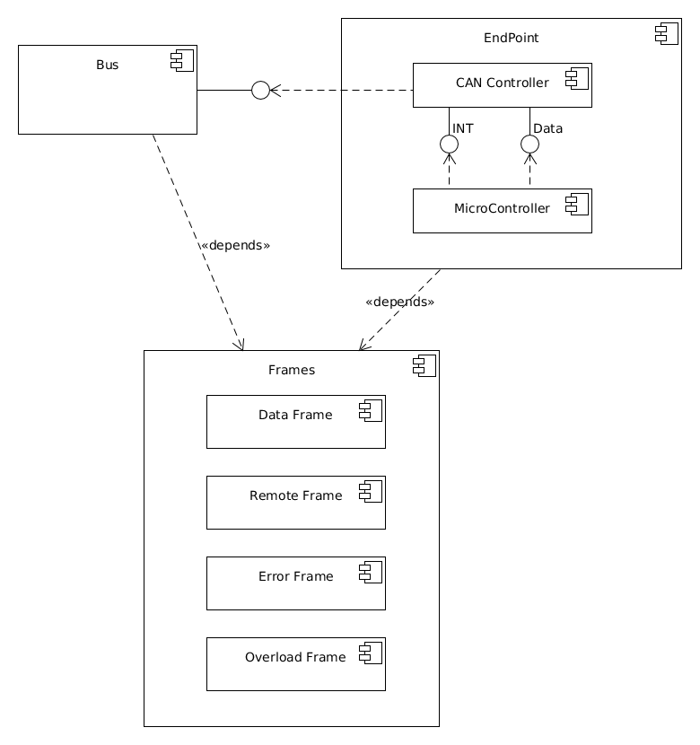

9.6. Scenarios
An example scenario would be consisting of the following components:
- One CAN bus
- 2 microcontrollers, each one having 1 CAN controller: a microcontroller for an engine heat sensor and the dashboard
At one point, the dashboard sends a message to the CAN bus, asking for the temperature measured by the heat sensor. The heat sensor’s CAN controller receives the message, sends the interrupt to its corresponding microcontroller, then sends the response back to the dashboard.
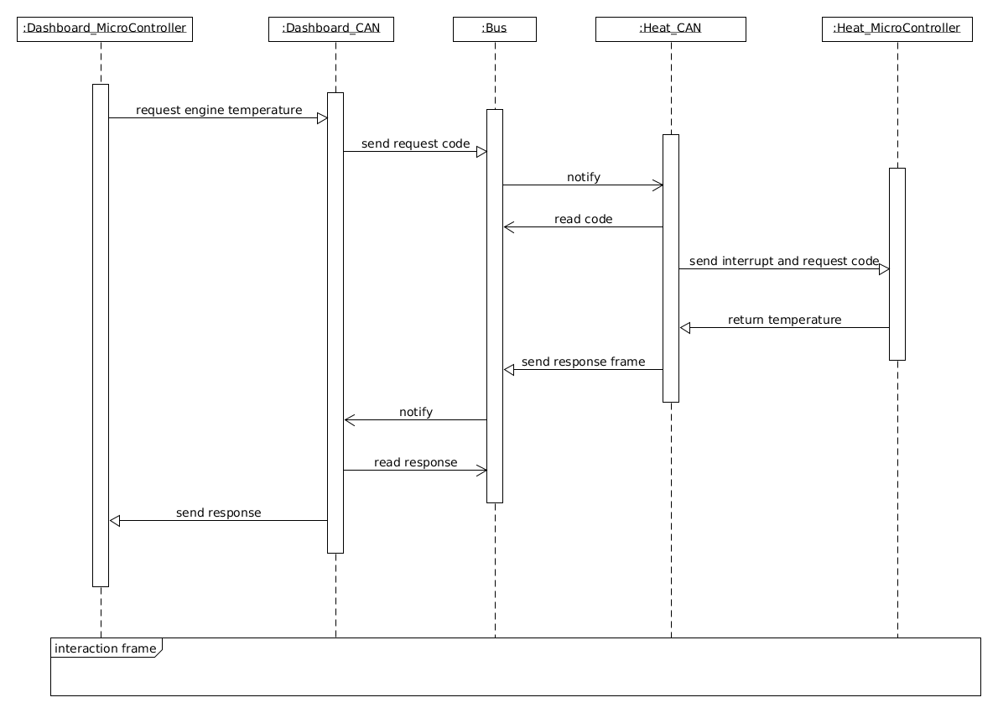

9.7. Graphical User Interface
The GUI should be simple, intuitive and responsive. The following elements are considered to be some basic ones:
- Load design button
- Save design button
- Design view, containing all the active components
- Component pane, containing all the user defined components
- Load example design menu, containing a list of predefined designs
- Create component button
- A message history pane, containing a list of all messages transmitted through the bus and their status (SUCCESS, ERROR etc.)

10. Implementation

10.1. Frame package
The frame package contains the frame classes, used by the Controller instances for communication. Its contents are:
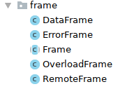

The Frame class is abstract and acts as a base for the other (concrete) classes.
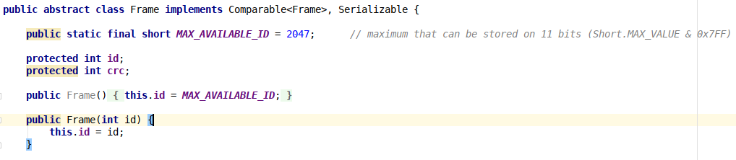
Since a frame can transmit 11 bits long Ids, the maximum value possible is 2047. When a frame is created, if the ID is not specified, the lowest priority is assigned (0 = highest priority, reserved for errors, 1 for overloads, 2047 = lowest priority).

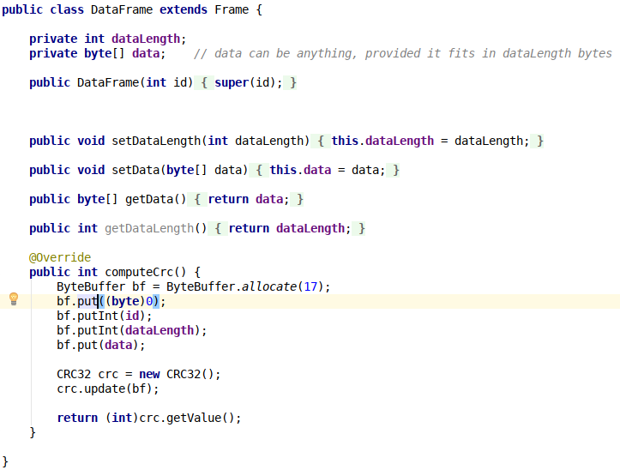
DataFrame is a concrete implementation of the Frame class. It is differentiated from the other classes by the presence of the dataLength field, which can have values in range [0...8]. Thus, it must also have its own implementation of the computeCrc() method, which is used for error detection.

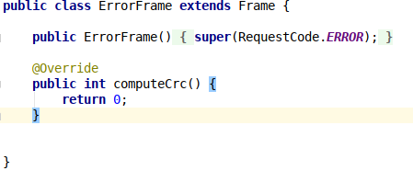

An error frame doesn’t transmit any data (except dominant and recessive bits at hardware level), so the computeCRC() method isn’t useful. Important to note is the RequestCode.ERROR id, which has the highest priority.

10.2. CAN Controller and ECU
There are 2 types of controllers implemented:
- CAN Controller (Controller class)
- ECU (MicroController abstract class and its concrete implementations)

10.2.1. CAN Controller
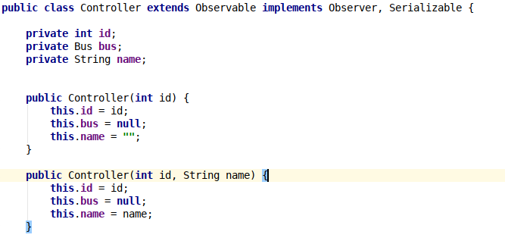

A CAN Controller contains 3 fields:
- ID : the id of the CAN Controller, auto-generated
- bus : the bus associated to the CAN Controller
- name : the name of the CAN Controller
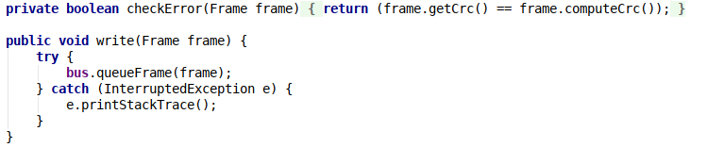

The checkError() method checks if there have been errors in transmitting a certain frame, by recomputing the frame’s CRC and comparing the returned value to the CRC field inside the frame. The write() method sends the frame to the bus.

10.2.2. ECU
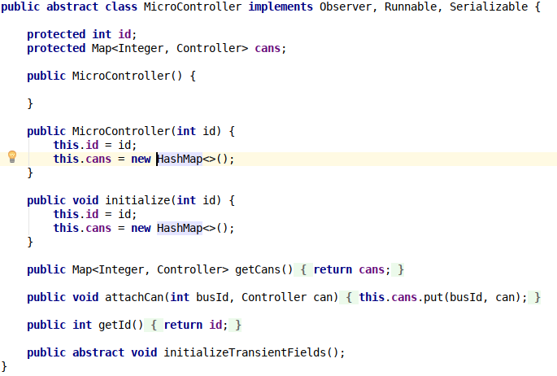

The MicroController class serves as a base for implementing specific microcontroller classes, such as an Engine class or a Dashboard class. An ECU can be connected to multiple buses, therefore it needs to store all the Controller references in a map.
An example concrete implementation is presented below:
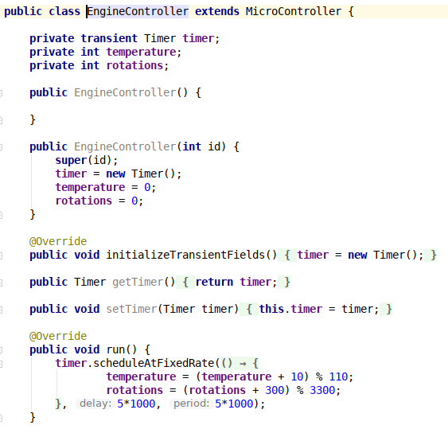

In this example, an engine is represented by its 2 properties: the temperature and rotations passed. Since every MicroController instance must run in a separate thread, they must implement the run() method, where the state evolution is described.
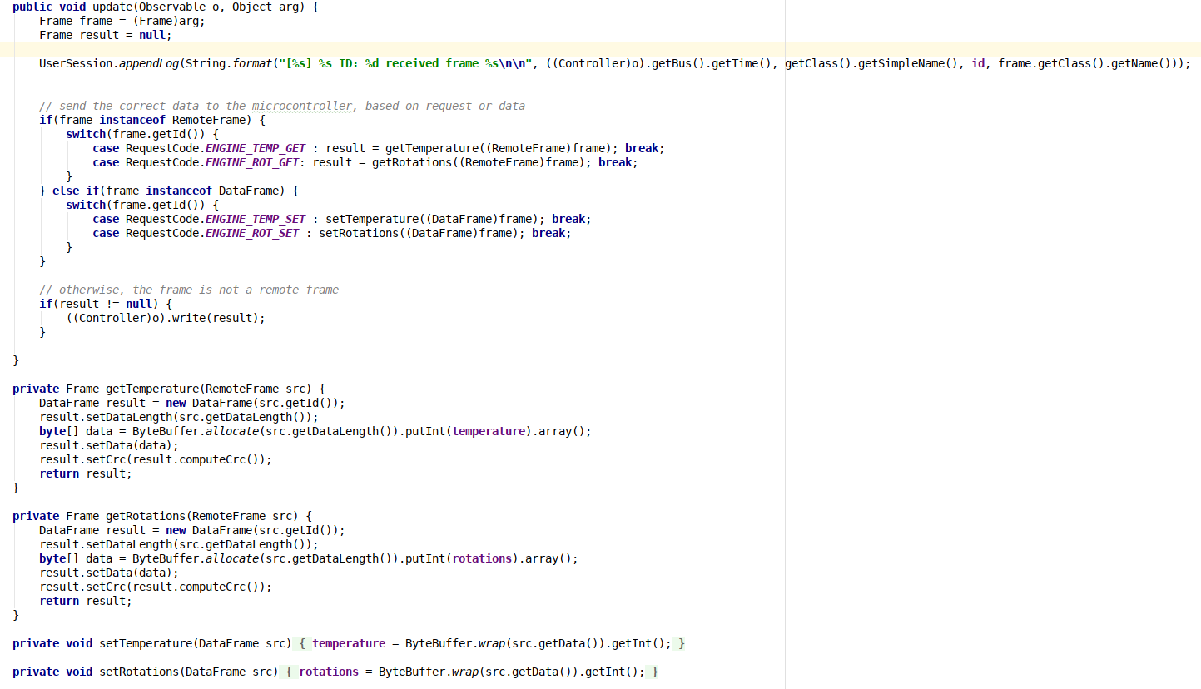
The update() method is called when one of the attached CAN Controllers receives a message. Depending on the received message, the MicroController calls the appropriate method and, if necessary, sends the result back to the Bus.

10.3. Bus
The Bus class tries to mimmick the behaviour of a real CAN message bus.
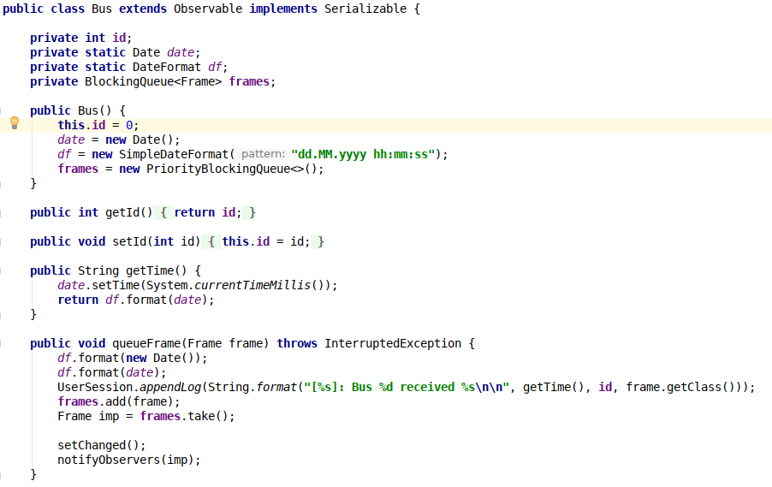
At any moment, it two or more CAN controllers send a message to the bus, the one having the highest priority is retained and sent to to all controllers. This is implemented by using a PriorityBlockingQueue, so the message having the lowest ID is always the first one to be extracted and, in case of multiple parallel accesses, the data is guaranteed to be valid.

11. Testing
Multiple functionalities have been tested using the graphical user interface, including:
- Creating multiple controller instances having the same ID
- Checking the timestamps printed in the user events log
- Deleting a certain Bus also removes all associated CAN Controllers

12. Bibliography
http://microcontroller.com/learn-embedded/CAN1_sie/CAN1big.htm
http://www.can-wiki.info/doku.php

